Fig. S4
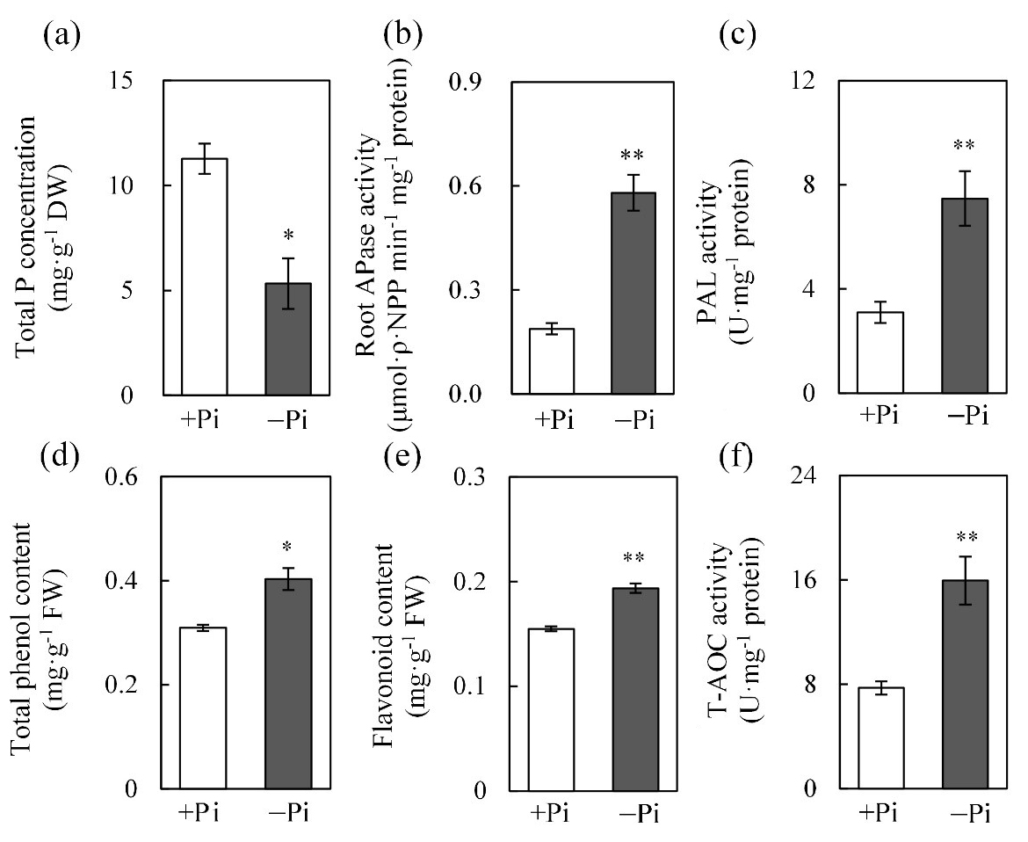
Malate concentration
(μg .g⁻¹ FW)
***
+Pi
−Pi
(g)
Malate exudation rate
(μg .g⁻¹ .24h⁻¹ FW)
***
+Pi
−Pi
(h)

Additional file 1: Fig. S4 Physiological and biochemical levels in stylo roots response to low P stress. (a) Total P concentration of shoots and roots; (b) APase activity; (c) PAL activity; (d) total phenol content; (e) flavonoid content; (f) T-AOC activity; (g) malate concentration; (h) malate exudation rate. Stylo seedlings were precultured in hydroponics for 7 d with 250 μmol/L KH₂PO₄ and subsequently transferred into nutrient solution with (+Pi) or without (−Pi) 250 μmol/L KH₂PO₄ additions for 15 d. Each bar represents the mean of four replicates with SE (n = 4). Asterisks represent significant differences between +Pi and −Pi treatments in the Student’s t-test (*: P < 0.05, **: 0.001 < P < 0.01, ***: P < 0.001). P: phosphate, APase: acid phosphatase, T-AOC: total antioxidant capacity, PAL: phenylalanine ammonia lyase, DW: dry weight, FW: fresh weight.

